Functional Requirements of Food Ordering Application System

# Objective

The objective of a food ordering application system is to provide a convenient and efficient platform for users to order food from restaurants or food establishments. The system aims to simplify the process of food ordering, enhance user experience, and streamline the overall operation. The system will offer users a convenient way to browse menus, customize their orders, and place them with just a few clicks or taps. It eliminates the need for traditional phone calls or physical visits to the restaurant. Overall, the food ordering application system will create a user-friendly platform that simplifies the food ordering process, enhances user experience, and benefits.

# Features Supported in Application

**Functions available for Admins are as follows:**

1. Access to add employee records
2. Managing the list of restaurants or food establishments registered on the platform
3. Access to view customer info
4. View and manage orders placed through the system

# Functions available for Users/Customers are as follows:

1. View menu
2. Adding of selected food items to their cart for ordering
3. Track the status of their orders in real-time
4. View their order history
5. Provide feedback and ratings

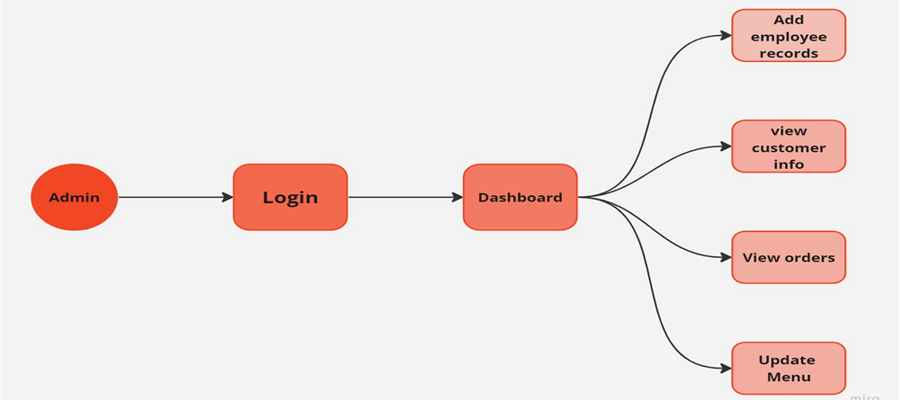

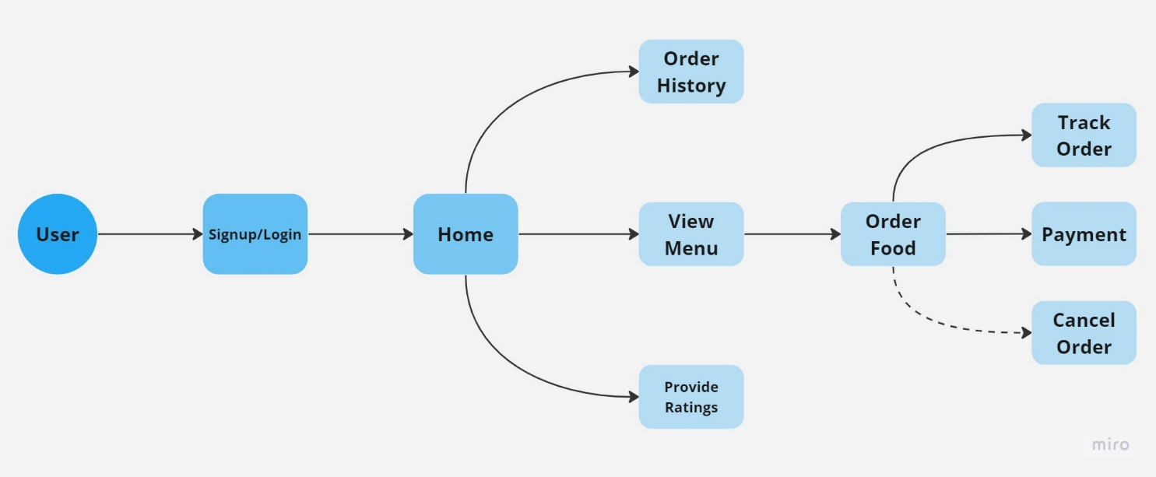

# Features for Admin:

*Login > Dashboard > Add employee records*

*AND*

*Login > Dashboard > Updating Menu*

*AND*

*Login > Dashboard > view customer info*

*AND*

*Login > Dashboard > View and manage orders*

On the dashboard page provided for the admins to view a dashboard that provides information about the system, such as the adding of employee records, managing list of restaurants, viewing of information of customers and orders.

**Field Name Description**

|  |  |
| --- | --- |
| Add Employee Records | Allows the admins to add employee information |
| Updating Menu | Allow the admin to add, view and update restaurants |
| View Customer info | Allow the admin to view information of customers |
| View Orders | Allow the admin to view and manage the orders |

# Admin Interactions:

1. To **Add Employee Records**, select the **Add** option in the dashboard.

All the related fields will appear on the screen as a table which can be updated and downloaded by clicking on **Add Employee Records** button.

1. To **Manage List of Restaurants**, select the **Manage** option in the dashboard.

All the details will appear on the screen which can be viewed and updated, and also at the top of the table Number of Restaurants are Shown.

1. To **View Customer Info**, select the **View** option in the dashboard.

All the details will appear on the screen and at the top of the table Number of Customers are Shown.

1. To **View Orders**, select the **View** option in the dashboard.

All the details will appear on the screen which can be managed and updated as per requirements, and at the top of the table Number of orders are Shown.

Click **Back to Dashboard** to navigate back to the dashboard

# Features for Users:

# *Signup/Login > Home > View Menu*

*AND*

# *Signup/Login > Home > View Menu > Order Food*

*AND*

# *Signup/Login > Home > View Menu > Order Food > Payment*

*AND*

# *Signup/Login > Home > View Menu > Order Food > Track Order*

*AND*

# *Signup/Login > Home > View Menu > Provide ratings*

*AND*

# *Signup/Login > Home > Order History*

When the user opens the application, user will be displayed with the Signup/Login page. After Providing the essential information then user is directed to home page. Where user can find View menu option, List of different restaurants and foods will be available.

So, there is order food option after the View Menu page. Then user is directed to payment page.

User is given with a Track Order option, so that user can check the food delivery status.

From the home page the user is also having an option to view their Order History, and Give Ratings option.

**Field Name Description**

|  |  |
| --- | --- |
| View Menu | Display a list of restaurants and foods. |
| Order Food | Allows User to Order the food. |
| Track Order | Allows User to check the status of food. |
| View Order History | Allows user to view previous orders. |
| Provide Ratings | Allow user to provide feedback or Ratings. |

# User’s Interactions:

1. For users there will be a **Signup/Login** option, where user is directed to home page.
2. To **View Menu,** Open the application. This will take the user to dashboard, where list of

restaurants and foods are shown.

1. To **Order Food,** user can select a restaurant and food, and it will redirect to order food option.
2. To **Track Order**, Click the view order option and status of food delivery can be checked.
3. To **View Order History,** User will be able to check the previous orders.
4. To **Provide Ratings**, user will have to click the option and submit ratings.

Click **Back to Home** to navigate back to the Home. Click **Logout** to logout.